Practical - 4
Practical Title: JavaScript DOM Manipulation, Event Handling, and UI Interactivity
Problem Definition: Add dynamic UI components such as collapsible FAQ, modal popup,
image/content slider, notification banner, hamburger menu, and light/dark
theme switcher using JavaScript.
Theory:
1.How are DOM elements selected and modified?
-> DOM elements are selected using methods like document.querySelector() and modified by changing properties like textContent, classList, or inline styles.
2.Are event listeners attached correctly?
-> Event listeners are attached correctly by using addEventListener(event, callback) on valid DOM targets to trigger logic when user actions occur.
3. Is localStorage used for remembering theme choice?
-> Yes, localStorage.setItem() and getItem() are used to save and retrieve the user's theme choice across page refreshes.
4. Does interactivity improve usability without breaking accessibility?
-> Yes, interactivity improves usability when paired with semantic HTML, keyboard navigation, and ARIA attributes to maintain full accessibility.
Implementation/ Output/Result :
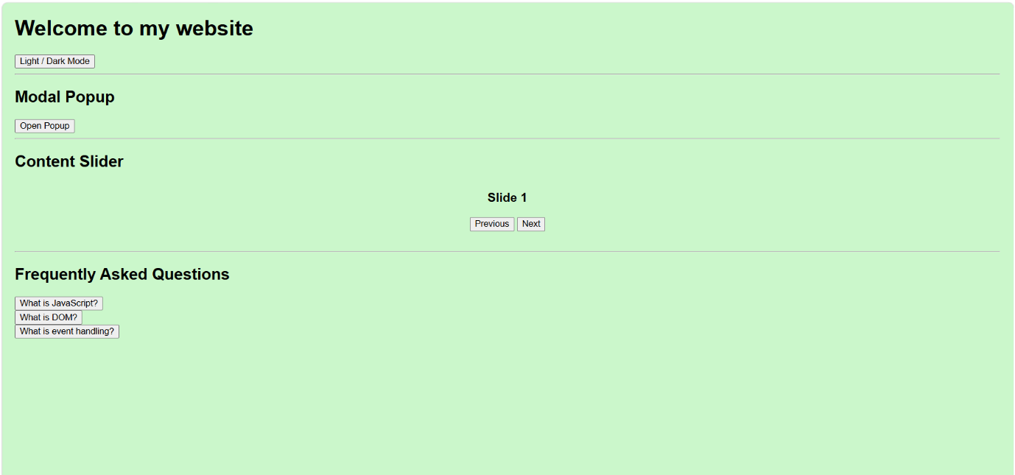
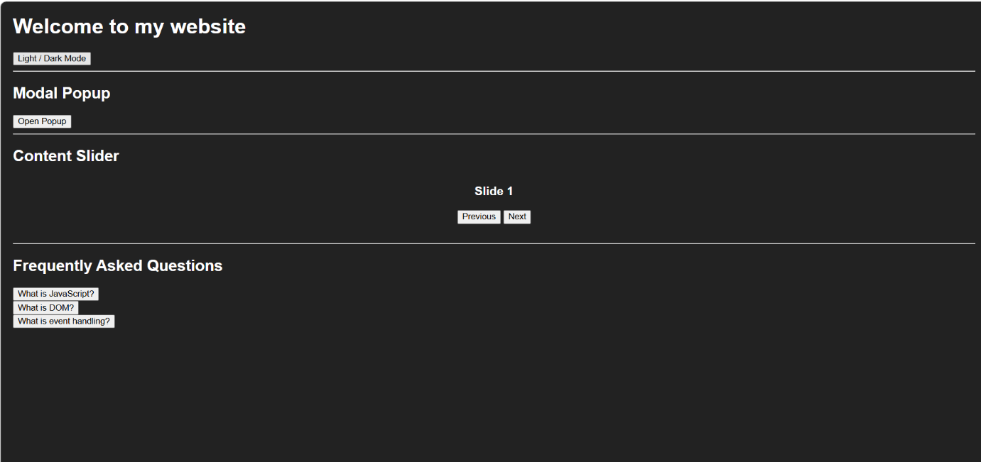
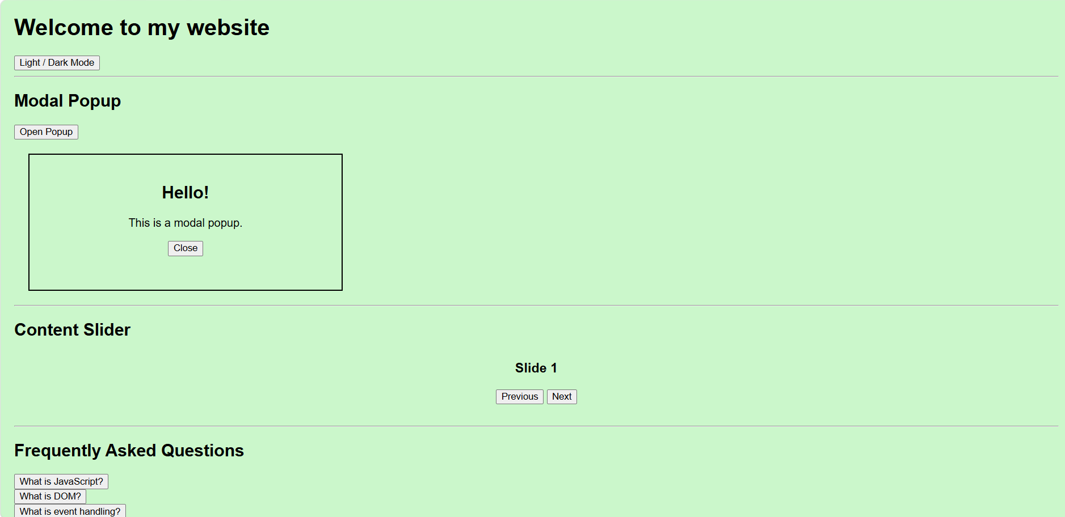
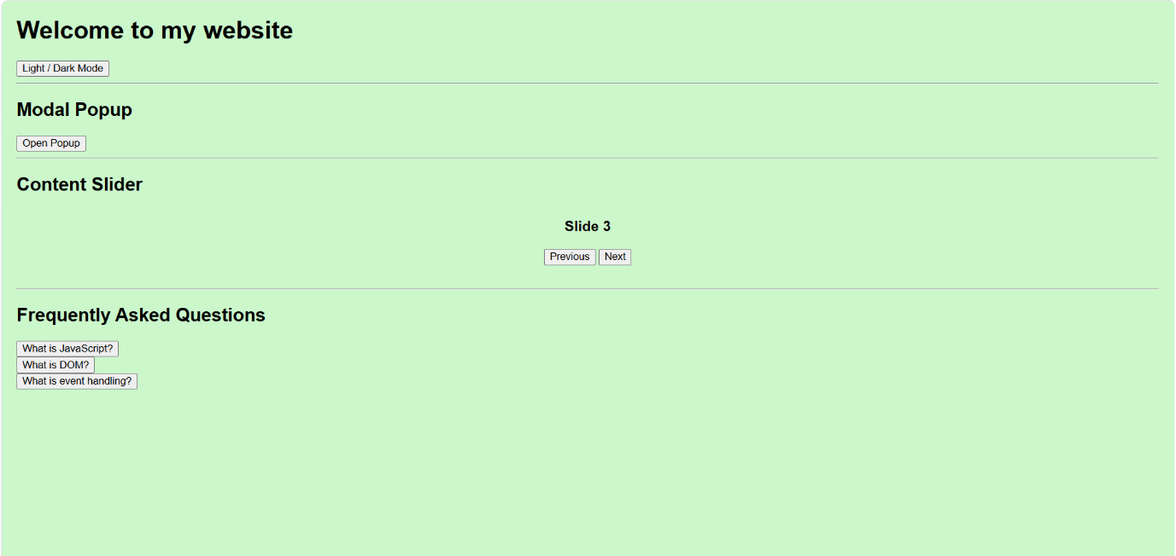
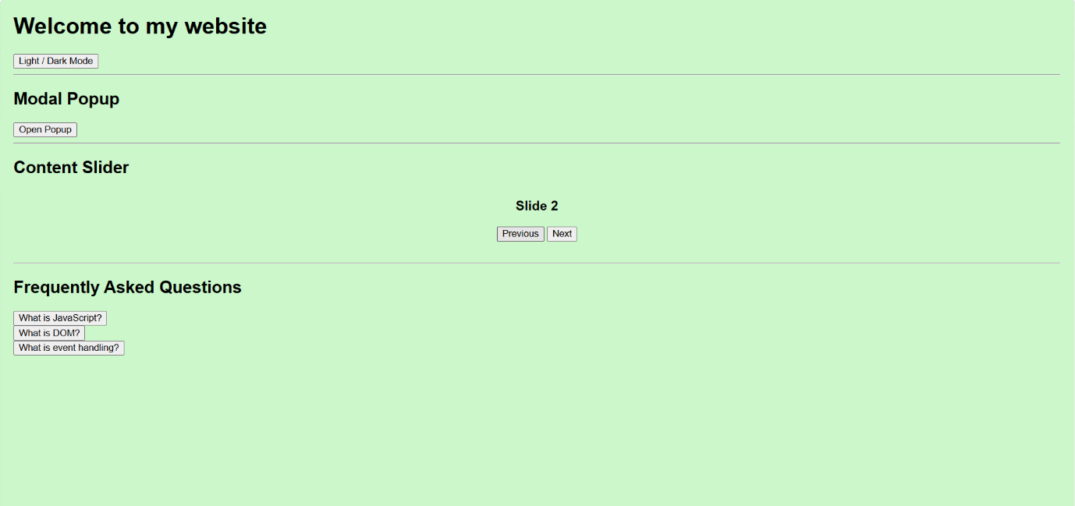
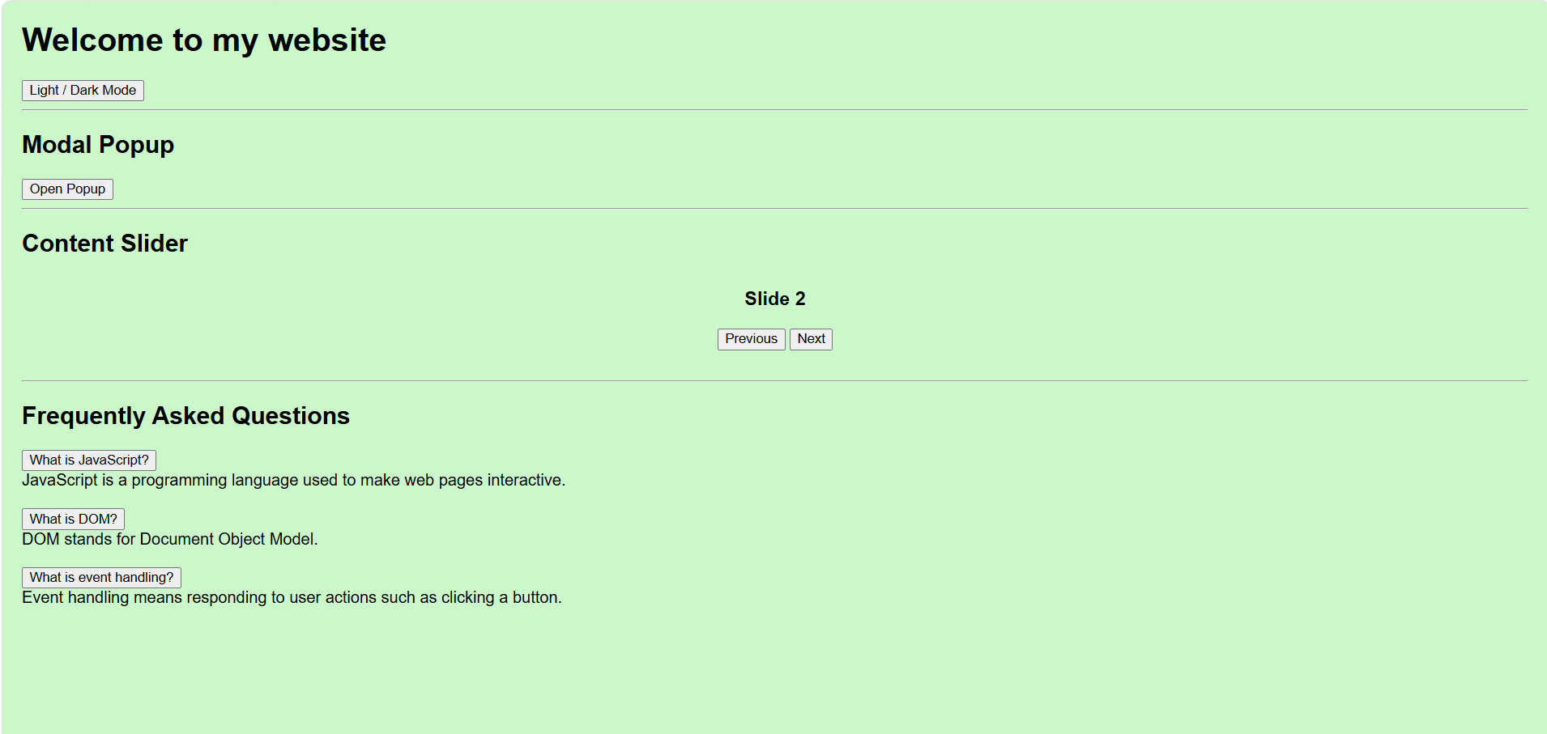

- GitHub Repository Link:
StudentHub/JavaScript at main · savaliyariya03/StudentHub

- Challenges Faced:
I faced challenges in implementing JavaScript in all this functions like change modes popup box, sliding window and etc.

- Learning Outcomes:
I learned how to change light mode to dark mode and sliding window and popup box and collapsible FAQ.

- Faculty Remarks:

